Requirements Analysis Document

- Use Case Diagram
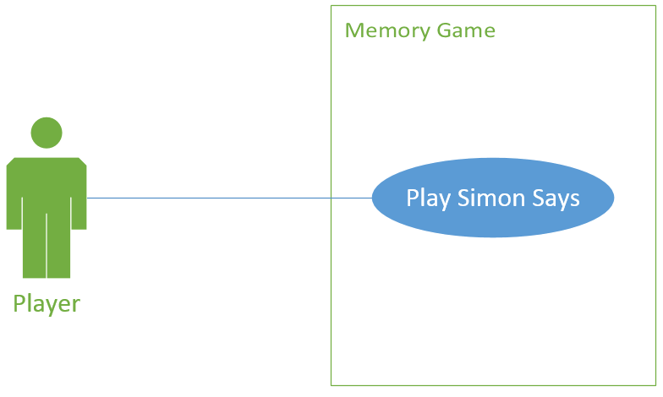
- Use Cases and Scenarios

1 Player: John
Scenario:
First, John logs into his account to access the game.
Next, John starts a game of Simon Says choosing to use 24 circles, squares, and triangles. The objects are medium sized. The objects are red, blue, green, purple, orange, or yellow and are arranged in a grid layout.
During round one, John is shown a sequence of activated objects. John matches the pattern and proceeds to the next round.
On round two, John is shown the same sequence with a new object added to the end of the sequence. He again matches the pattern and proceeds to the next round.
On round three, John is shown another sequence with a new object, but incorrectly repeats the pattern. This ends the game and displays John’s score.

- Glossary/ data dictionary
- Non-functional requirements(URPS)
- Constraints(+)
- Domain Model
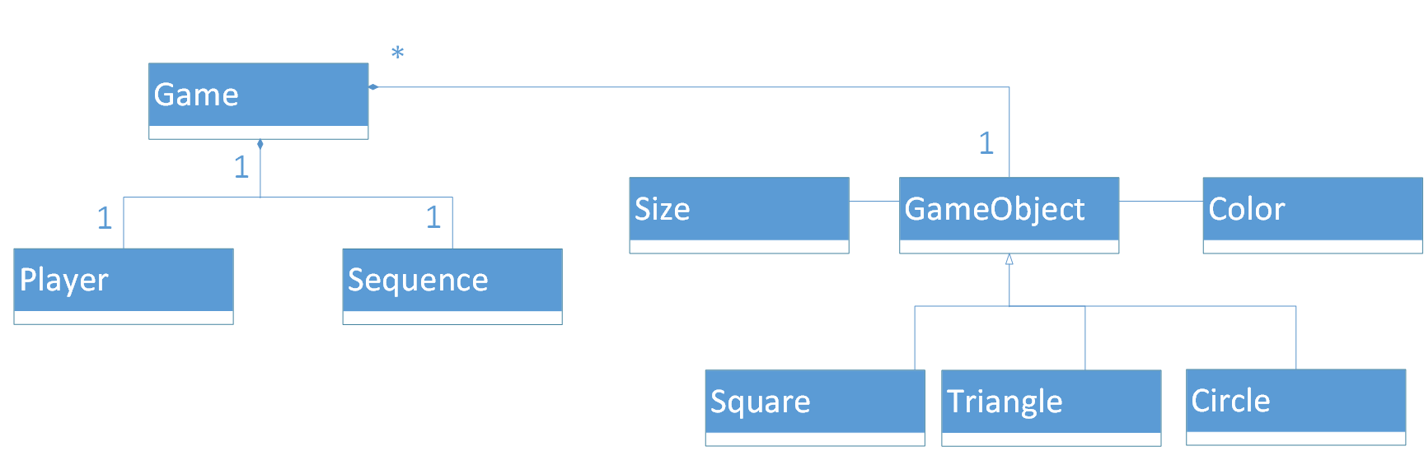

- System sequence diagrams
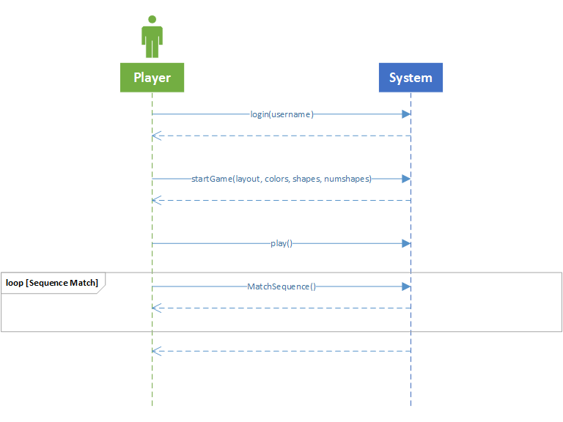

- State models

Simon Says

Login
Select layout

Play game
Record score
Game ends
Login Panel

Enter Username
Create username if none exist

Login
Game starts

Setup Panel

User selects number of objects
User selects Shapes
User selects colors
User selects layout
User selects Object size
Game starts

Game

Computer generates pattern
User enters pattern
Score is recorded
Game ends when
Wrong pattern is selected

- User interface mockups
